**CMS ID: _______________________ Name: _________________________**

**Course:** Database Management System (Lab) **Class:**

**Instructor:**   **Time Allowed: 30** Mins

**Max. Marks:** 7 Marks **Date:** 27th May, 2023 (Final Exam)

Assume we are a music store and we want to have a report showing the top 10 best-selling albums of all time in our store.

We have four tables in our database name “**music**”:

1. **Albums** table: includes all the albums one per row and its details

**(**i.e album_id, album_name, artist_id, year, genre)

1. **Artists** table: includes all artists with their details i.e artist_id, artist_name, years_active, genre, awards.
2. **Customers** table: includes all customers with their details i.e customer_id, customer_name, email, phone_number, city.
3. **Sales** table: includes all sales with customer and album as foreign keys i.e sale_id, album_id, customer_id, date, purchase_price.

(**6 Marks**: 4 marks on creating tables, 1 mark on insert correct dummy information visible and not visible, 1 Mark on using the appropriate constraints)

1. Create a report that will show the top 10 best-selling albums of all time in our store with their artist name and total sales amount.

You may need to:

1. join the tables together to get all the required data
2. use a subquery to get the total sales amount for each album
3. order the result by the total sales amount in descending order

Expected Output: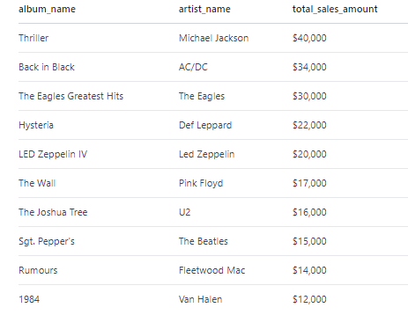

**\*\*\*\*\*\*\*\*\*\*\*\*\*\*\*\*\*\*\*\*\*\*\*\*\*\*\*\* THE END \*\*\*\*\*\*\*\*\*\*\*\*\*\*\*\*\*\*\*\*\*\*\*\*\*\*\***